

BANK MANAGEMENT

{USING MYSQL}



February 22, 2023

[VELAMMAL ENGINEERING COLLAGE]

[SURAPET]

|  |  |
| --- | --- |
| TEAM MEMBER | ROLL NO |
| RAGESHWARAN HR | 21 |
| BHARATH VAAISHNAV TB | 04 |
| PRANESH.S | 18 |

|  |
| --- |
| CSE A |

ABSTRACT:

This bank management system is built using the C programming language and MySQL database. The system provides a menu-driven interface for customers to perform various banking operations such as creating new accounts, checking balance, transferring funds, depositing and withdrawing money, checking account details, deleting customer records, applying for loans, checking loan status, and paying back loans.

The system starts with a welcome message and displays a menu with different options for the customers to choose from. The system uses functions to handle each option selected by the customer, such as creating a new account, checking balance, transferring funds, depositing and withdrawing money, and so on.

The system also allows customers to apply for loans and check their loan status. Additionally, the system has the functionality to delete customer records in case a customer wants to close their account.

Overall, this bank management system provides an efficient and user-friendly way for customers to perform banking operations, making it easier for the bank to manage its operations and customer records.

SOURCE CODE:

#include <mysql.h>

#include <stdio.h>

#include <stdlib.h>

#include <string.h>

#define DB_HOST "localhost"

#define DB_USER "root"

#define DB_PASS "ragesh2004"

#define DB_NAME "bankmanagements"

void auth(MYSQL*);

void menu(MYSQL*);

void new_acc(MYSQL*);

void check_balance(MYSQL*);

void transfer(MYSQL*);

void deposit(MYSQL*);

void withdraw(MYSQL*);

void check_details(MYSQL*);

void delete_customer(MYSQL*);

void apply_loan(MYSQL*);

void check_loan_status(MYSQL*);

void pay_back_loan(MYSQL*);

void menu(MYSQL *con)

{

int a;

printf("\n\n\t\t==========Welcome to RB bank of india ==========\n\n");

printf("\n\t\t----Please choose one of the options below----\n");

printf("\n\t\t<1> create new Accounts \n");

printf("\n\t\t<2> Check Balance\n");

printf("\n\t\t<3> bank transfer\n");

printf("\n\t\t<4> Deposit\n");

printf("\n\t\t<5> Withdraw\n");

printf("\n\t\t<6> check details \n");

printf("\n\t\t<7> delete customer\n");

printf("\n\t\t<8> apply loan\n");

printf("\n\t\t<9> check loan status\n");

printf("\n\t\t<10> pay_back_loan\n");

printf("\n\t\t<11> Exit\n\n");

printf("\n\n\t\t===============================================\n\n");

printf("enter the choice: ");

scanf("%d", &a);

switch (a)

{

case 1:

new_acc(con);

break;

case 2:

check_balance(con);

break;

case 3:

transfer(con);

break;

case 4:

deposit(con);

break;

case 5:

withdraw(con);

break;

case 6:

check_details(con);

break;

case 7:

delete_customer(con);

break;

case 8:

apply_loan(con);

break;

case 9:

check_loan_status(con);

break;

case 10:

pay_back_loan(con);

case 11:

exit(0);

default:

printf("Invalid choice.\n");

break;

}

}

void auth(MYSQL *con)

{

char name[50];

char emp_pin[10];

char query[200];

printf("Enter your name: ");

scanf("%s", name);

printf("Enter your employee pin: ");

scanf("%s", emp_pin);

sprintf(query, "SELECT *FROM employee WHERE name='%s' AND

emp_pin='%s'", name, emp_pin);

if (mysql_query(con, query))

{

fprintf(stderr, "%s\n", mysql_error(con));

mysql_close(con);

exit(1);

}

MYSQL_RES *result = mysql_store_result(con);

if (result == NULL)

{

fprintf(stderr, "%s\n", mysql_error(con));

mysql_close(con);

exit(1);

}

int num_fields = mysql_num_fields(result);

MYSQL_ROW row;

if ((row = mysql_fetch_row(result)))

{

printf("Authentication successful.\n");

}

else

{

printf("Authentication failed.\n");

mysql_close(con);

exit(1);

}

mysql_free_result(result);

}

void new_acc(MYSQL *con)

{

char name[50];

char email[50];

char phone_number[20];

char address[1000];

char adhar_number[20];

char query[500];

char pin[6];

char amount[20];

int num_fields;

char accountno[11];

printf("Enter customer name: ");

scanf("%s", name);

printf("Enter customer email: ");

scanf("%s", email);

printf("Enter customer phone number: ");

scanf("%s", phone_number);

printf("Enter customer address: ");

scanf(" %[^\n]", address);

printf("Enter customer adhar number: ");

scanf("%s", adhar_number);

printf("Enter initial amount: ");

scanf("%s", &amount);

printf("Enter account number: ");

scanf("%s", accountno);

printf("Enter your pin: ");

scanf("%s", &pin);

sprintf(query, "INSERT INTO customers (name, email, phone_number, address, adharnumber, amount, pin, accountnumber) VALUES ('%s', '%s', '%s', '%s', '%s', '%s', '%s', '%s')", name, email, phone_number, address, adhar_number, amount, pin, accountno);

int status = mysql_query(con, query);

if (status != 0)

{

printf("Failed to create account.\n");

}

else

{

if (mysql_affected_rows(con) > 0)

{

printf("Account created successfully.\n");

}

else

{

printf("Failed to create account.\n");

}

}

menu(con);

}

void check_balance(MYSQL *con)

{

char from_acc[12], pin[4];

char query[200];

printf("Enter the account number to check balance: ");

scanf("%s", from_acc);

printf("Enter your pin: ");

scanf("%s", pin);

sprintf(query, "SELECT *FROM customers WHERE accountnumber='%s' AND pin='%s' ", from_acc, pin);

if (mysql_query(con, query))

{

fprintf(stderr, "%s\n", mysql_error(con));

mysql_close(con);

exit(0);

}

MYSQL_RES *result = mysql_store_result(con);

if (result == NULL)

{

fprintf(stderr, "%s\n", mysql_error(con));

mysql_close(con);

exit(0);

}

int num_fields = mysql_num_fields(result);

MYSQL_ROW row;

if ((row = mysql_fetch_row(result)))

{

printf("Your balance is: %s\n", row[6]);

}

else

{

printf("No customer found with adhar number %s.\n", from_acc);

}

mysql_free_result(result);

menu(con);

}

void withdraw(MYSQL *con)

{

char from_acc[12], pin[4];

char query[200], new_balances[20];

int amount;

printf("Enter the account number to withdraw: ");

scanf("%s", from_acc);

printf("Enter your pin: ");

scanf("%s", pin);

sprintf(query, "SELECT *FROM customers WHERE accountnumber='%s' AND pin='%s'", from_acc, pin);

if (mysql_query(con, query))

{

fprintf(stderr, "%s\n", mysql_error(con));

mysql_close(con);

exit(0);

}

MYSQL_RES *result = mysql_store_result(con);

if (result == NULL)

{

fprintf(stderr, "%s\n", mysql_error(con));

mysql_close(con);

exit(0);

}

int num_fields = mysql_num_fields(result);

MYSQL_ROW row;

if ((row = mysql_fetch_row(result)))

{

printf("Enter amount to withdraw: ");

scanf("%d", &amount);

int balance = atoi(row[6]);

int new_balance = balance - amount;

if (new_balance < 0)

{

printf("Withdrawal amount exceeds balance. Please try again.\n");

}

else

{

sprintf(new_balances, "%d", new_balance);

sprintf(query, "UPDATE customers SET amount=%s WHERE

accountnumber='%s'", new_balances, from_acc);

if (mysql_query(con, query))

{

fprintf(stderr, "%s\n", mysql_error(con));

mysql_close(con);

exit(1);

}

else

{

printf("Withdrawal successful. New balance is: %d\n", new_balance);

}

}

}

else

{

printf("No customer found with accountnumber %s.\n", from_acc);

}

mysql_free_result(result);

menu(con);

}

void deposit(MYSQL *con)

{

char from_acc[12], pin[4];

char amount_str[20];

int amount;

char query[200];

char new_balances[20];

printf("Enter the account number to deposit : ");

scanf("%s", from_acc);

printf("Enter your pin: ");

scanf("%s", pin);

sprintf(query, "SELECT *FROM customers WHERE accountnumber='%s' AND

pin='%s'", from_acc, pin);

if (mysql_query(con, query))

{

fprintf(stderr, "%s\n", mysql_error(con));

mysql_close(con);

exit(0);

}

MYSQL_RES *result = mysql_store_result(con);

if (result == NULL)

{

fprintf(stderr, "%s\n", mysql_error(con));

mysql_close(con);

exit(0);

}

int num_fields = mysql_num_fields(result);

MYSQL_ROW row;

if ((row = mysql_fetch_row(result)))

{

printf("Enter amount to deposit: ");

scanf("%s", amount_str);

amount = atoi(amount_str);

int current_balance = atoi(row[6]);

int new_balance = current_balance + amount;

sprintf(new_balances, "%d", new_balance);

sprintf(query, "UPDATE customers SET amount=%s WHERE accountnumber='%s'", new_balances, from_acc);

if (mysql_query(con, query))

{

fprintf(stderr, "%s\n", mysql_error(con));

mysql_close(con);

exit(1);

}

printf("deposit successful. New balance is: %d\n", new_balance);

}

else

{

printf("No customer found with accountnumber %s.\n", from_acc);

}

mysql_free_result(result);

menu(con);

}

void transfer(MYSQL *con)

{

char from_acc[20], pin[4];

char to_acc[20];

int amount;

char query[500];

char from_acc_amount[20];

char to_acc_amount[20];

int flag = 0;

printf("Enter the account number to transfer from: ");

scanf("%s", from_acc);

printf("Enter your pin: ");

scanf("%s", pin);

printf("Enter the account number to transfer to: ");

scanf("%s", to_acc);

printf("Enter the amount to transfer: ");

scanf("%d", &amount);

sprintf(query, "SELECT *FROM customers WHERE accountnumber='%s' AND pin='%s'", from_acc, pin);

if (mysql_query(con, query))

{

fprintf(stderr, "%s\n", mysql_error(con));

mysql_close(con);

exit(0);

}

MYSQL_RES *result = mysql_store_result(con);

if (result == NULL)

{

fprintf(stderr, "%s\n", mysql_error(con));

mysql_close(con);

exit(0);

}

MYSQL_ROW row;

if ((row = mysql_fetch_row(result)))

{

int from_amount = atoi(row[0]);

if (from_amount >= amount)

{

from_amount -= amount;

sprintf(from_acc_amount, "%d", from_amount);

sprintf(query, "UPDATE customers SET amount='%s' WHERE accountnumber='%s'", from_acc_amount, from_acc);

if (mysql_query(con, query))

{

fprintf(stderr, "%s\n", mysql_error(con));

mysql_close(con);

exit(1);

}

flag = 1;

}

else

{

printf("Insufficient balance.\n");

}

}

else

{

printf("No customer found with account number %s.\n", from_acc);

}

if (flag == 1)

{

sprintf(query, "SELECT amount FROM customers WHERE accountnumber='%s'",

to_acc);

if (mysql_query(con, query))

{

fprintf(stderr, "%s\n", mysql_error(con));

mysql_close(con);

exit(0);

}

result = mysql_store_result(con);

if (result == NULL)

{

fprintf(stderr, "%s\n", mysql_error(con));

mysql_close(con);

exit(0);

}

if ((row = mysql_fetch_row(result)))

{

int to_amount = atoi(row[0]);

to_amount += amount;

sprintf(to_acc_amount, "%d", to_amount);

sprintf(query, "UPDATE customers SET amount='%s' WHERE accountnumber='%s'", to_acc_amount, to_acc);

if (mysql_query(con, query))

{

fprintf(stderr, "%s\n", mysql_error(con));

mysql_close(con);

exit(1);

}

printf("Amount transferred successfully.\n");

}

else

{

printf("No customer found with account number %s.\n", to_acc);

}

}

mysql_free_result(result);

menu(con);

}

void check_details(MYSQL *con)

{

char from_acc[12], pin[4];

char query[200];

printf("Enter the account number to check balance: ");

scanf("%s", from_acc);

sprintf(query, "SELECT *FROM customers WHERE accountnumber='%s'", from_acc);

if (mysql_query(con, query))

{

fprintf(stderr, "%s\n", mysql_error(con));

mysql_close(con);

exit(0);

}

MYSQL_RES *result = mysql_store_result(con);

if (result == NULL)

{

fprintf(stderr, "%s\n", mysql_error(con));

mysql_close(con);

exit(0);

}

int num_fields = mysql_num_fields(result);

MYSQL_ROW row;

if ((row = mysql_fetch_row(result)))

{

printf("Name: %s\n", row[1]);

printf("Email: %s\n", row[2]);

printf("Phone number: %s\n", row[3]);

printf("Address: %s\n", row[4]);

printf("Adhar number: %s\n", row[5]);

printf("Account balance: %s\n", row[6]);

printf("Account number: %s\n", row[8]);

}

else

{

printf("No customer found with account number %s.\n", from_acc);

}

mysql_free_result(result);

menu(con);

}

void delete_customer(MYSQL *con)

{

char account_number[11];

char query[500];

printf("Enter the account number of the customer you want to delete: ");

scanf("%s", account_number);

sprintf(query, "DELETE FROM customers WHERE accountnumber = '%s'", account_number);

if (mysql_query(con, query))

{

fprintf(stderr, "%s\n", mysql_error(con));

mysql_close(con);

exit(1);

}

int num_rows_affected = mysql_affected_rows(con);

if (num_rows_affected > 0)

{

printf("Customer deleted successfully.\n");

}

else

{

printf("Customer not found.\n");

}

menu(con);

}

void apply_loan(MYSQL *con)

{

char accountno[11];

char loan_amount[20];

char interest_rate[10];

char duration[10];

char query[500];

char Query[500];

int loan_id;

int balance;

printf("Enter account number: ");

scanf("%s", accountno);

printf("Enter loan amount: ");

scanf("%s", loan_amount);

printf("Enter interest rate (in percentage): ");

scanf("%s", interest_rate);

printf("Enter loan duration (in months): ");

scanf("%s", duration);

sprintf(query, "INSERT INTO loans (accountnumber, amount, interest_rate, duration) VALUES ('%s', '%s', '%s', '%s')", accountno, loan_amount, interest_rate, duration);

if (mysql_query(con, query))

{

fprintf(stderr, "%s\n", mysql_error(con));

mysql_close(con);

exit(1);

}

loan_id = mysql_insert_id(con);

printf("Loan application submitted successfully. Your loan id is: %d\n", loan_id);

menu(con);

}

void check_loan_status(MYSQL *con)

{

char loanid[20];

int loan_id;

char query[200];

char is_paid[15];

printf("Enter loan ID: ");

scanf("%s", loanid);

loan_id = atoi(loanid);

sprintf(query, "SELECT *FROM loans WHERE loan_id=%d", loan_id);

if (mysql_query(con, query))

{

fprintf(stderr, "%s\n", mysql_error(con));

mysql_close(con);

exit(0);

}

MYSQL_RES *result = mysql_store_result(con);

if (result == NULL)

{

fprintf(stderr, "%s\n", mysql_error(con));

mysql_close(con);

exit(0);

}

int num_rows = mysql_num_rows(result);

if (num_rows == 0)

{

printf("Loan not found.\n");

}

else

{

MYSQL_ROW row = mysql_fetch_row(result);

printf("Loan ID: %s\n", row[0]);

printf("accountn number: %srs\n", row[1]);

printf("amount: %s%\n", row[2]);

printf("Interest rate: %s%%\n", row[3]);

printf("duration: %s\n", row[4]);

strcpy(is_paid, row[5]);

if (strcmp(is_paid, "paid") == 0)

{

printf("Loan status: paid\n");

}

else

{

printf("Loan status: unpaid\n");

}

}

mysql_free_result(result);

menu(con);

}

void pay_back_loan(MYSQL *con)

{

char loan_id_str[20];

int loan_id, old, amounts, months, rate;

char query[200], confirm;

char from_acc[12], pin[4];

char new_balance_str[20];

char Query[200];

printf("Enter loan ID: ");

scanf("%s", loan_id_str);

printf("Enter the months taken to pay: ");

scanf("%d", &months);

printf("Enter the interest rate in percentage: ");

scanf("%d", &rate);

loan_id = atoi(loan_id_str);

sprintf(query, "SELECT *FROM loans WHERE loan_id=%d", loan_id);

if (mysql_query(con, query))

{

fprintf(stderr, "%s\n", mysql_error(con));

mysql_close(con);

exit(1);

}

MYSQL_RES *result = mysql_store_result(con);

if (result == NULL)

{

fprintf(stderr, "%s\n", mysql_error(con));

mysql_close(con);

exit(1);

}

int num_rows = mysql_num_rows(result);

if (num_rows == 0)

{

printf("Loan not found.\n");

}

else

{

MYSQL_ROW row = mysql_fetch_row(result);

int is_paid = atoi(row[5]);

if (is_paid == 1)

{

printf("This loan has already been paid.\n");

}

else

{

printf("Loan ID: %s\n", row[0]);

printf("Amount given: $%s\n", row[2]);

old = atoi(row[2]);

amounts = old + (old *months *rate) / 100;

printf("Amount to be paid: $%d\n", amounts);

printf("Are you sure you want to pay back this loan? (y/n): ");

scanf(" %c", &confirm);

if (confirm == 'y' || confirm == 'Y')

{

printf("Enter the account number to withdraw: ");

scanf("%s", from_acc);

printf("Enter your PIN: ");

scanf("%s", pin);

sprintf(query, "SELECT *FROM customers WHERE

accountnumber='%s' AND pin='%s'", from_acc, pin);

if (mysql_query(con, query))

{

fprintf(stderr, "%s\n", mysql_error(con));

mysql_close(con);

exit(1);

}

result = mysql_store_result(con);

if (result == NULL)

{

fprintf(stderr, "%s\n", mysql_error(con));

mysql_close(con);

exit(1);

}

num_rows = mysql_num_rows(result);

if (num_rows == 0)

{

printf("Invalid account number or PIN.\n");

}

else

{

MYSQL_ROW row = mysql_fetch_row(result);

int balance = atoi(row[6]);

int new_balance = balance - amounts;

if (new_balance < 0)

{

printf("Withdrawal amount exceeds the balance.

Please try again.\n");

}

else

{

sprintf(new_balance_str, "%d", new_balance);

sprintf(query, "UPDATE customers SET amount='%s'

WHERE accountnumber='%s'", new_balance_str,

from_acc);

if (mysql_query(con, query))

{

fprintf(stderr, "%s\n", mysql_error(con));

mysql_close(con);

exit(1);

}

sprintf(Query, "UPDATE loans SET status='paid' WHERE

loan_id=%d", loan_id);

if (mysql_query(con, Query))

{

fprintf(stderr, "%s\n", mysql_error(con));

mysql_close(con);

exit(1);

}

printf("Loan successfully paid.\n");

}

}

}

}

mysql_free_result(result);

menu(con);

}

}

int main()

{

MYSQL *con = mysql_init(NULL);

if (con == NULL)

{

fprintf(stderr, "%s\n", mysql_error(con));

exit(1);

}

if (mysql_real_connect(con, DB_HOST, DB_USER, DB_PASS, DB_NAME, 0, NULL, 0) == NULL)

{

fprintf(stderr, "%s\n", mysql_error(con));

mysql_close(con);

exit(1);

}

auth(con);

menu(con);

mysql_close(con);

return 0;

}

TABLE:

Customer database in MYSQL:

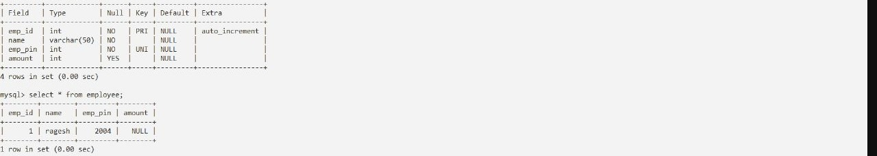

Employee database in MYSQL:

LOAN TABEL:

OUTPUT:

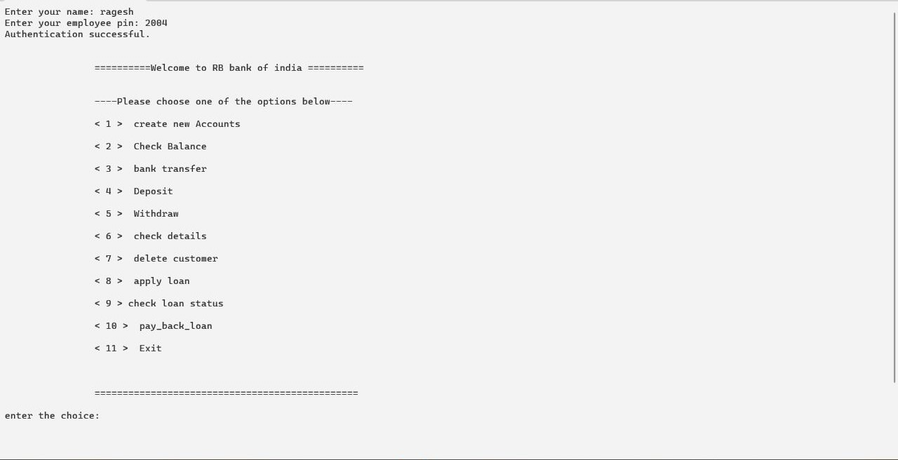MENU:

CREATE NEW ACCOUNT: -

CHECK BALANCE: -

BANK TRANSFER:-

DEPOSIT:-

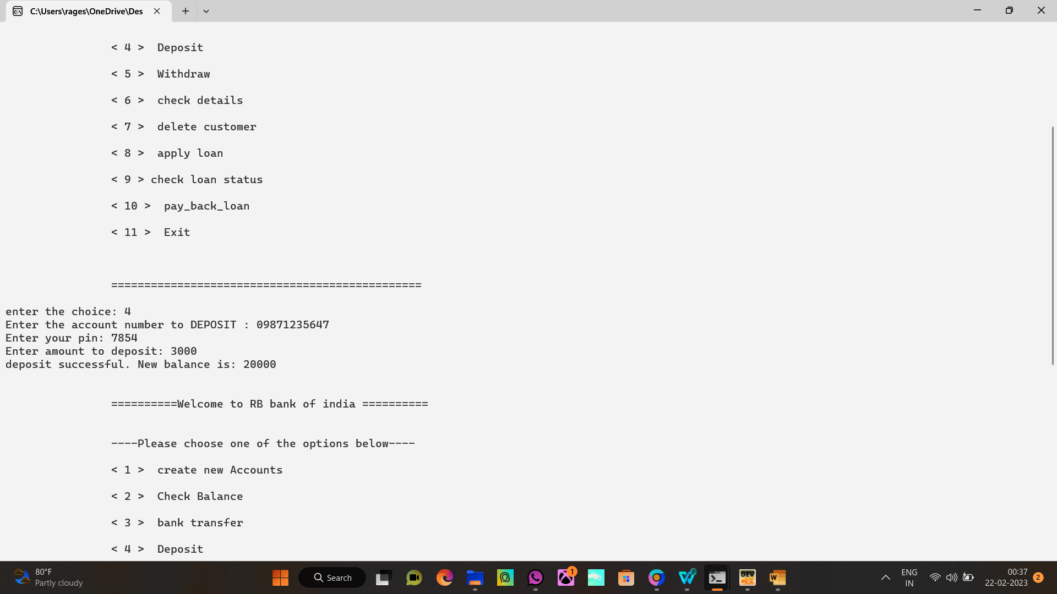

WITHDRAW: -

CHECK BALANCE: -

REMOVE CUSTOMER: -

LOAN

APPLY LOAN: -

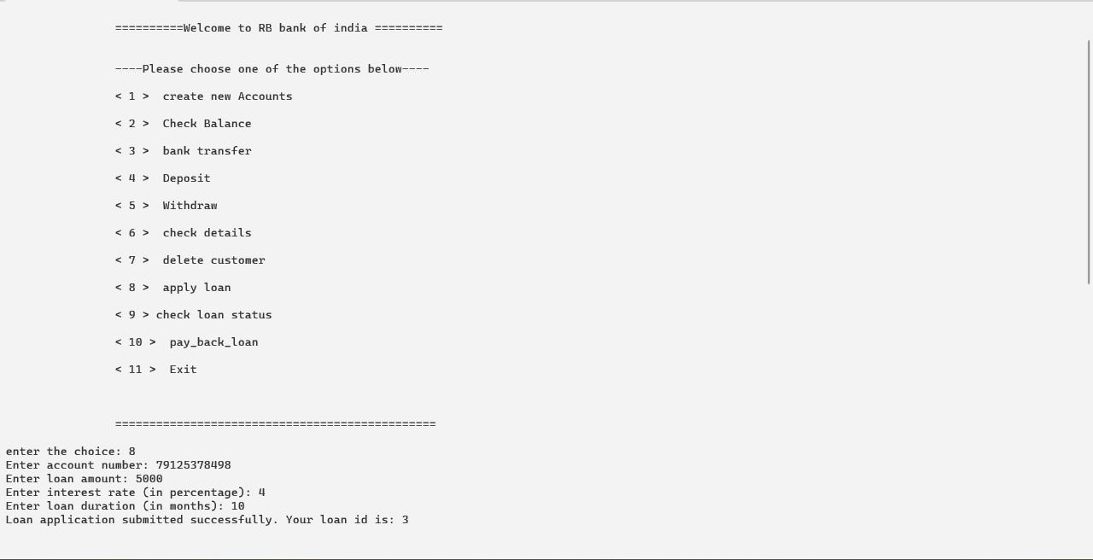

STATUS OF LOAN: -

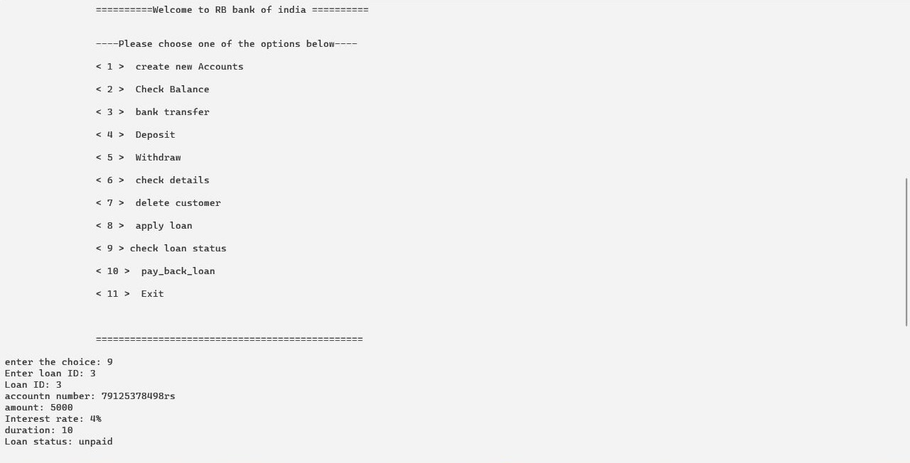

PAY BACK LOAN: -

CHECKING STATUS AFTER PAYING LOAN: -

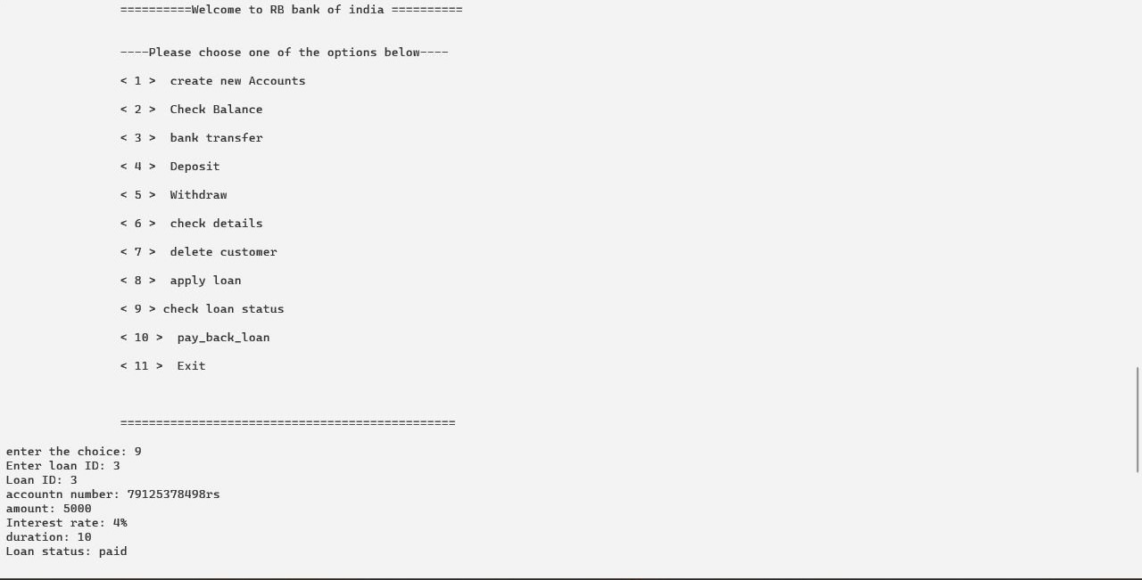

EXIT: -

